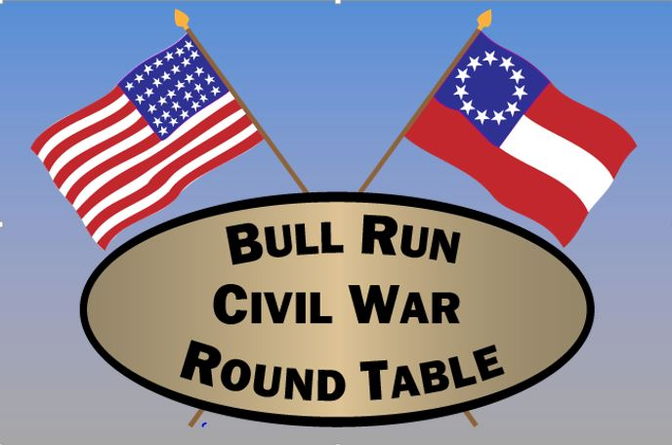
P.O. Box 2147, Centreville, VA 20122

http://www.bullruncwrt.org

a 501(c)(3) Organization

MEMBERSHIP FORM
The Bull Run Civil War Round Table

We are delighted that you are interested in joining our organization and look
forward to seeing you at our next meeting and at our upcoming events!

Annual dues are:

Family: $25.00
Individual: $20.00
Student: FREE
(Age 21 & under)

Make checks payable to: BRCWRT (Bull Run Civil War Round Table)

This form may be given to the President or Treasurer at the General Membership
meeting. Or mail it to:

BRCWRT Treasurer
P.O. Box 2147
Centreville, VA 20120

NAME_________________________________________________________________

ADDRESS_____________________________________________________________

CITY____________________________________STATE_________ZIP____________

PHONE__________________EMAIL_________________________________________

How did you learn about the BRCWRT?_____________________________________
(Friend, Facebook, Public Event etc.)

